SPRINT - 1

|  |  |
| --- | --- |
| Date | 30 October 2022 |
| Team ID | PNT2022TMID12349 |
| Project Name | Personal Assistance for Seniors Who Are Self- Reliant. |

1: Creating IBM Watson IOT Platform and device:

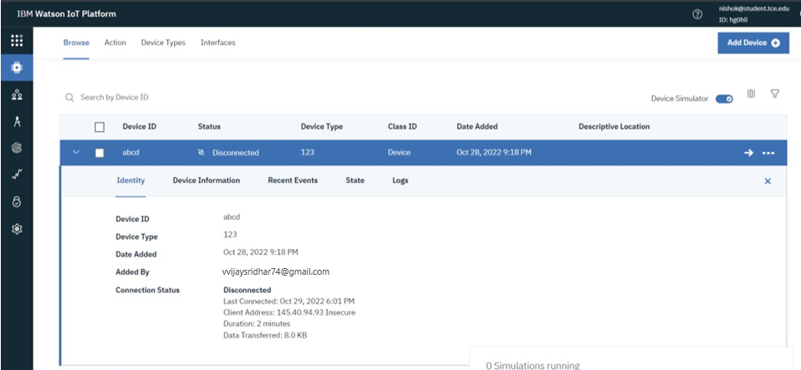

2: Creating Node-RED Service:

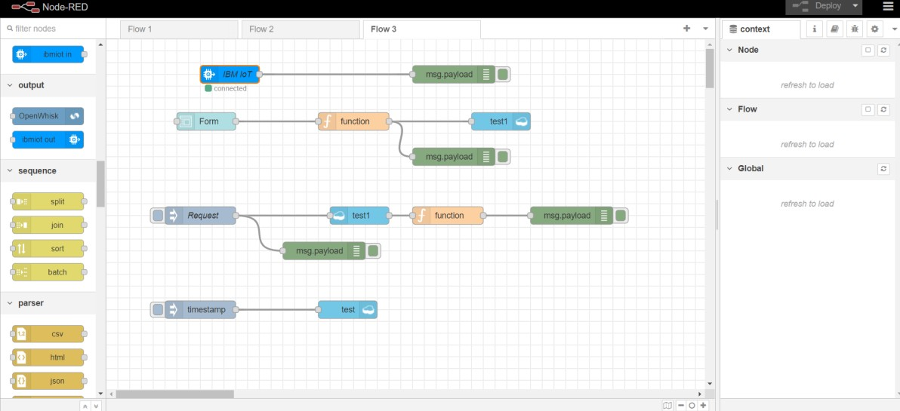

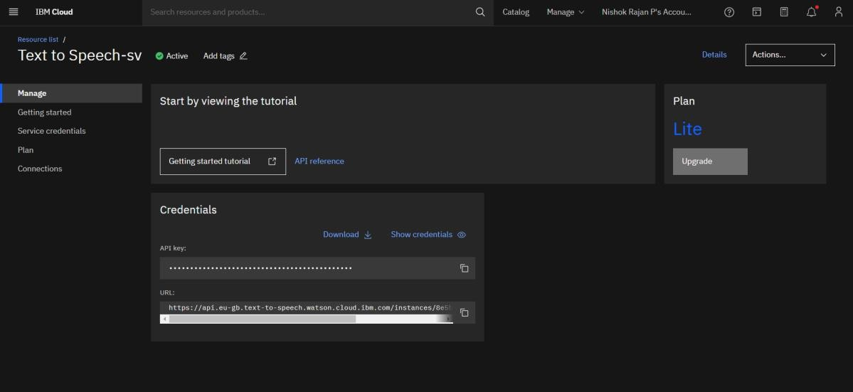 3:Creating Text to Speech Service:

4:Creating a Database in Cloudant DB:

